Practical information for participants

- VENUE
Keio Plaza Hotel Tokyo
Address: 2-2-1 Nishi-Shinjuku, Sinjuku-ku, Tokyo 160-8330, Japan
Tel: +81 3 3344 0111
Fax: +81 3 3345 8269
Website: http://www.keioplaza.com/
The area map nearby the Keio Plaza Hotel Tokyo is referred to Figure 1.

In the meeting room, delegates can connect to the Internet using their laptops with a wireless LAN card (802.11b/g). WEP key/ SSID will be informed at the venue.

- CONFERENCE FACILITIES AND REGISTRATION
For Participants of SG3 RG-AO, registration services will be available at the ASAHI room (Secretariat’s room) on the 44th floor during the specified times.
- Sunday 7 April between 15:00 and 18:00
- Monday 8 and Tuesday 9 April between 08:30 and 16:00
- Wednesday 10 April between 08:30 and 11:00
The meeting will open at 09:00 hours at the AKEBONO room next to the ASAHI room.

- ACCESS TO The Keio Plaza Hotel Tokyo
Participants from foreign countries will enter Japan through Narita Airport (New Tokyo International Airport) or Haneda Airport (Tokyo International Airport)
Narita Airport: http://www.narita-airport.jp/en/index.html
Haneda Airport: http://www.haneda-airport.jp/inter/en/
The recommended transportation options from either airport to the venue are described in following below.

  - From Narita Airport to the Keio Plaza Hotel Tokyo
- Narita Airport limousine
There is a direct limousine bus from Narita Airport to the Keio Plaza Hotel Tokyo.
Airport ticket counters are located in the arrival lobbies of terminal 1 and 2 at the Narita Airport. The Airport limousine bound for the Keio Plaza Hotel Tokyo leaves every 30 to 40 min and takes about 120 min. For more detailed information, please see the following Web site:
Airport limousine: http://www.limousinebus.co.jp/en/platform_searches/index/2/18

- JR Narita Express train
The JR Narita Express (N’EX) bound for Sinjuku Station (or Ikebukuro Station) leaves every 30 to 60 min and takes about 90 min. It takes 5 min by walking from West Exit, Shinjuku Station to the Keio Plaza Hotel Tokyo. For more detailed information, please see the following Web site:
JR Narita Express (N’EX) train:
http://www.narita-airport.jp/en/access/train/index.html
http://jreast-shinkansen-reservation.eki-net.com/pc/english/common/timetable/e_nex_u/index.html

  - From Haneda Airport to the Keio Plaza Hotel Tokyo
- Haneda Airport limousine
There is a direct limousine bus from Haneda Airport to the Keio Plaza Hotel Tokyo.
The Airport limousine bound for the Keio Plaza Hotel Tokyo leaves every 60 min and take about 75 min. For more detailed information, please see the following Web site:
Airport limousine: http://www.limousinebus.co.jp/en/platform_searches/index/4/18

The figures below show the several ways and details to access to the venue from Narita Airport or Haneda Airport.

- HOTELS
  - Keio Plaza Hotel Tokyo
The Keio Plaza Hotel Tokyo has hold rooms for the participants of SG3 RG-AO at the following preferential rates.
Room Rate (JPY)
(including breakfast)
Single use | 16,000
Twin use | 18,000
All reservation requests must be made no later than 17th of March 2013. Availability and room rates are not guaranteed after this date. Participants are requested to book directly to the hotel by sending e-mail using the Reservation Form 2. The reservation will be valid upon receipt for confirmation from the Keio Plaza Hotel Tokyo by fax or e-mail.

  - Other Hotels in Shinjuku area
The following hotels are recommended in Shinjuku area. Participants are requested to book your hotel room by contacting directly to the hotel. Rooms of below three hotels have not been hold for participants of SG3 RG-AO, therefore, participants are requested to book their hotel rooms as early as possible.

 |  | Room Rate (SAMPLE,JPY) |  | Remark
Shinjuku Washington Hotel |  | Single use | 14,400 - 15,400 | 6 minute walk to the venue
Shinjuku Washington Hotel |  | Twin use | 17,000 – 20,000 | 6 minute walk to the venue
Shinjuku Washington Hotel | URL | http://shinjuku.washington-hotels.jp/ |  | 6 minute walk to the venue
Kadoya Hotel |  | Single use | 7,560 - 11,870 | 2 minute walk to the venue
Kadoya Hotel |  | Twin use | 13,650 - 17,750 | 2 minute walk to the venue
Kadoya Hotel | URL | http://www.kadoya-hotel.co.jp/eng/ |  | 2 minute walk to the venue
Keio Presso Inn Shinjuku |  | Single use | 9,400 | 8 minute walk to the venue
Keio Presso Inn Shinjuku |  | Twin use | 13,500 | 8 minute walk to the venue
Keio Presso Inn Shinjuku | URL | http://www.presso-inn.com/en/hotel/shinjuku.html |  | 8 minute walk to the venue
The locations of these three hotels are referred to Figure 1.

- VISA AND IMMIGRATION INFORMATION:
Participants who require a visa should apply for a visa at a Japanese consulate or diplomatic mission in their respective country well in advance of their departure.
Participants are also advised to contact their local travel agents or carriers. The Embassy may take at least two weeks for visa processing.
For more information, please visit the website of the Ministry of Foreign Affairs of Japan at:
http://www.mofa.go.jp/j_info/visit/visa/

Participants who need an invitation letter and/or visa supporting documents for entering Japan shall fill out all items in Application Form 3, then fax or email the form to the following contact point together with a copy of photograph page of the passport no later than 6th of March 2013.

Hideki Suganami (Mr.) / Junkichi Fujisawa (Mr.)
The ITU Association of Japan
Phone: +81 3 5357 7625/+81 3 5357 7626
Fax: +81-3-3356-8170
E-mail: sg3-visa@ituaj.jp (Email is the preferable communication means.)

- TECHNICAL TOUR
Half day Technical Tour will be planned. Detail will be announced at the meeting.

- PRACTICAL INFORMATION
  - About Tokyo:
Tokyo, the capital of Japan, is one of the largest cities of the world with a population of 13-million.
http://www.metro.tokyo.jp/ENGLISH/
  - Weather:
The temperature in Tokyo during April ranges from 5 to 15urary degrees centigrade. Average rainfall in April is about 130 mm in Tokyo.
  - Time Zone: GMT + 9 hours.
  - Banks & Currency:
The Japanese currency unit is Japanese Yen (JPY). There are four kinds of bills (10,000 yen, 5,000 yen, 2,000 yen and 1,000 yen) and six kinds of coins (500 yen, 100 yen, 50 yen, 10 yen, 5 yen and 1 yen) used. Only Japanese Yen (JPY) is accepted at stores and restaurants. Major foreign currencies may be exchanged to JPY at foreign exchange banks at the International Airports on presentation of your passport. Japanese banks are usually open Monday to Friday from 9:00 to 15:00. The exchange rate as of 15th February 2012 is 91 Japanese Yen to 1 US Dollar. Major credit cards are accepted by most hotels, restaurants, department stores, but not local small shops.
  - Tipping: Tipping is not customary in Japan.
  - Electricity: The standard power supply in Japan is 100 volts. The frequency is 50 Hz in eastern Japan including Tokyo. The type of power outlet/connector used in Japan is
A type which is a two-parallel-pronged type.

- LOCAL CONTACT POINT:
For any information and arrangement of the events please contact:
INAMI Toshiyuki (Mr.)
Standardization Division, Ministry of Internal Affairs and Communications
Phone: +81-3-5253-5771, Fax: +81-3-5253-5764
E-mail: sg3-local@ml.soumu.go.jp
(Email is the preferable communication means)

Transportation from Narita or Haneda Airport to the Venue
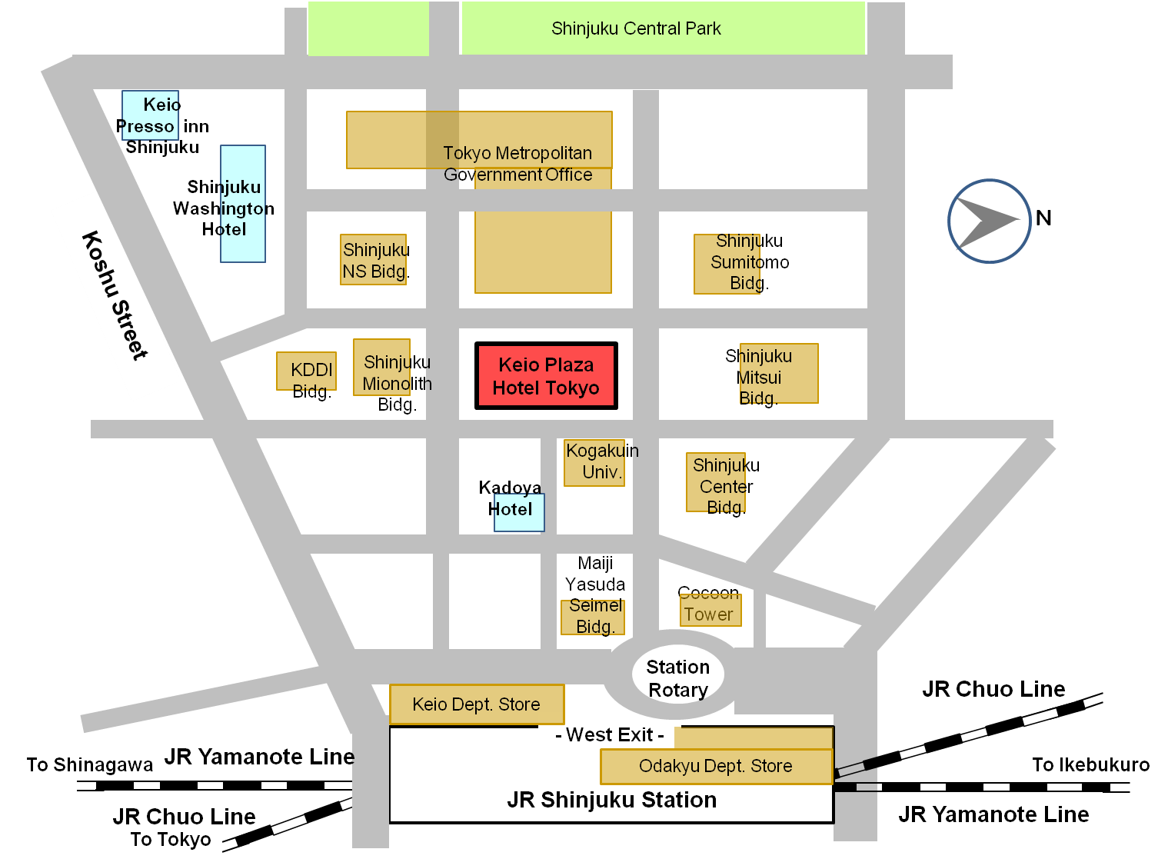

Figure 1 - Area Map nearby Keio Plaza Hotel Tokyo
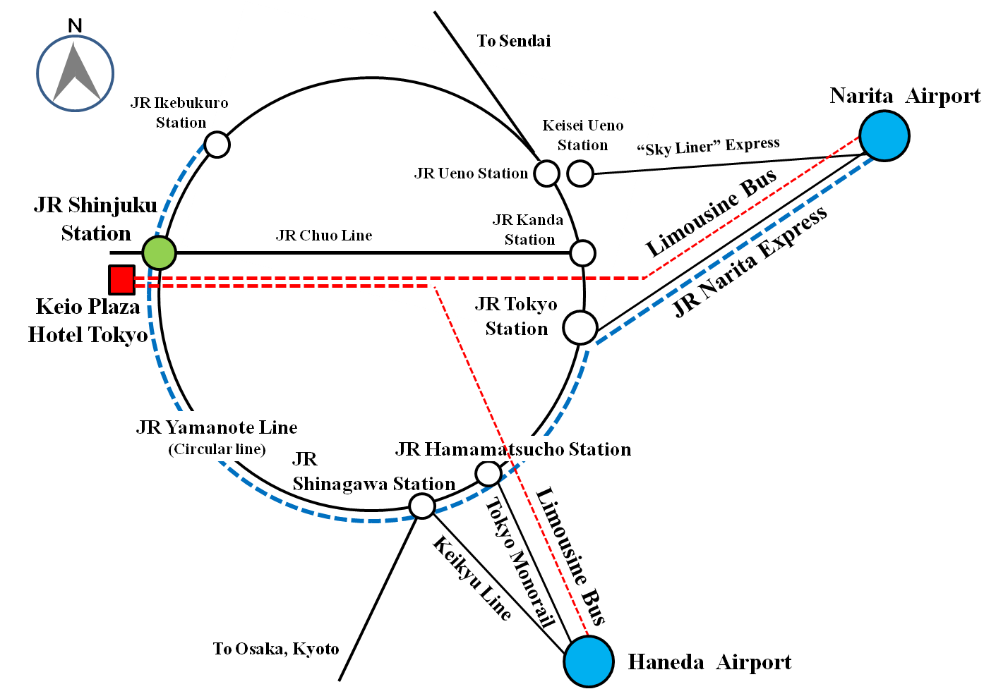

Figure 2 - Transportation Map from Narita Airport or Haneda Airport

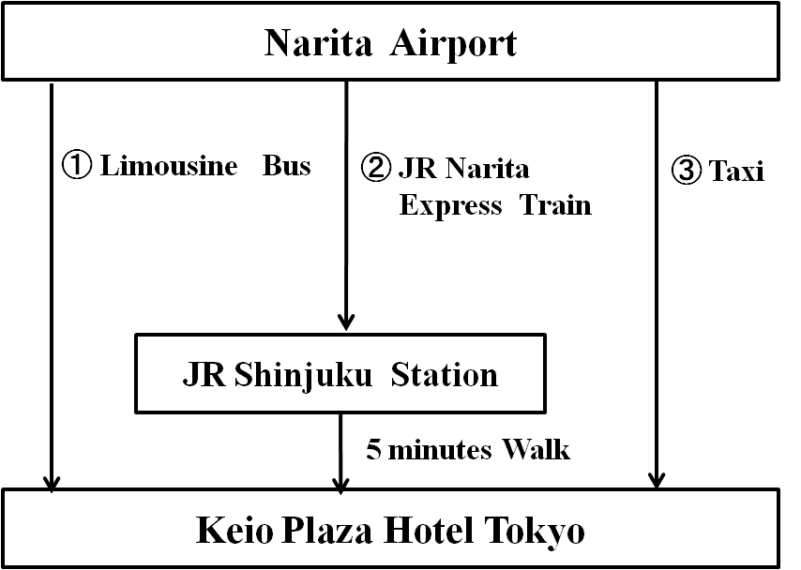

Figure 3 - Transportation from Narita Airport to the Venue

Table 1 - Time required and Vehicle Fee of Transportation from Narita Airport to the Venue
(Numbers in row correspond to numbers in Figure 3)
No. | Vehicle | Approx. Time Required (minutes) | Vehicle Fee  (JPY) | Remarks
1 | Limousine bus | 120 | 3,000
2 | JR Narita Express Train | 90 | 2,940
3 | Taxi | 100 | approx. 24,000 | not including expressway fare

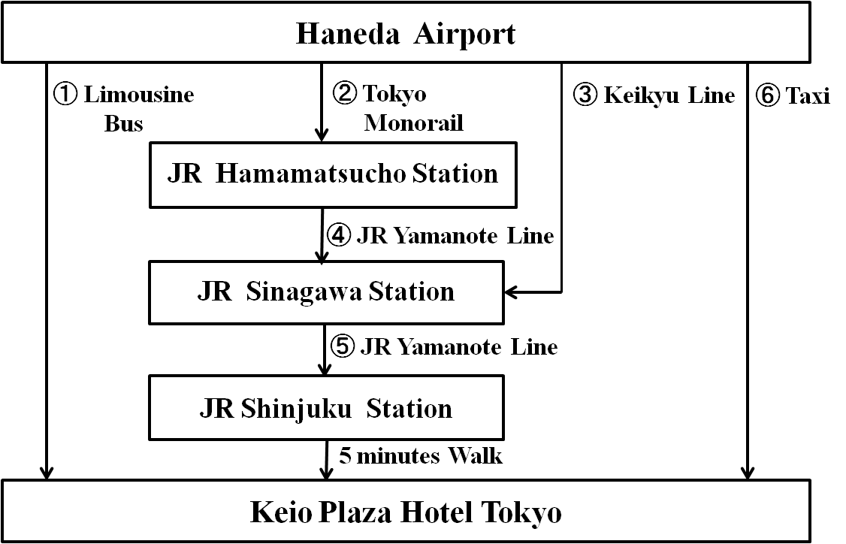

Figure 4 - Transportation from Haneda Airport to the Venue

Table 2 - Time required and Vehicle Fee of Transportation from Haneda Airport to the Venue
(Numbers in row correspond to numbers in Figure 4)
No. | Vehicle | Approx. Time Required (minutes) | Vehicle Fee  (JPY) | Remarks
1 | Limousine bus | 75 | 1,200
2 | Tokyo Monorail | 20 | 470
3 | Keikyu Line | 20 | 400
4 | JR Yamanote Line | 6 | 190
5 | JR Yamanote Line | 19 | 190
6 | Taxi | 50 | approx.8,600 | not including expressway fare

FORM 2 – Keio hotel reservation form
(to TSB Collective letter 1/SG3RG-AO)
ITU-T SG3 RG-AO
Tokyo, Japan, 8-10 April 2013
PLEASE complete and return this form by e-mail to: Hotel Reservation Counter (E-mail Address: rooms-sales@keioplaza.co.jp )
Deadline of Submission : 17TH of MARCH 2013 - SG3RG-AO

Name:
(Mr. Ms. Dr.):
 | Family Name |  | Middle Name |  | Given Name

Organization:
Full Address: (Office Home)

Country:

Address:

Phone No. Fax No. E-mail

Name of Accompanying Person(s), if any:
(Mr. Ms. Dr.):
 | Family Name |  | Middle Name |  | Given Name

PASSPORT INFORMATION:

Passport No. : Expiry Date: / / (DD/MM/YYYY)

Nationality:

Room Type :
Single use (15,000 JPY) Twin use (18,000 JPY)

Check-in and Check-out Date:
Check in date: / / (DD/MM/YYYY) Check out date: / / (DD/MM/YYYY)
Smoking or Non Smoking
Smoking Room Non Smoking Room
Credit Card
MasterCard VISA JCB American Express Diners Club
Card number:
Name of card holder: Expiry Date : / / (DD/MM/YYYY)

Conformation Reply from Hotel:
Fax Your Fax No.
E-mail Your E-mail Address
Date: Signature:

FORM 3 – Application form for Visa Supporting document
(to TSB Collective letter 1/SG3RG-AO)

ITU-T SG3 RG-AO
Tokyo, Japan, 8-10 April 2013
Application Form for Visa Supporting Documents

Name

(Mr. Ms. Dr.)

Family Name Middle Name Given Name
Your full name in Chinese characters(*):
*If you are a Chinese participant, please write your name in Chinese characters.

Official Title

Department:

Organization
(**):
**If you are a Chinese participant, please write your organization in Chinese characters as well.

Country (where you live)

Address (*1):
(*1) VISA supporting documents will be sent to the address above by courier service.

Phone No. Fax No. E-mail

PASSPORT INFORMATION:

Passport No. : Date of Issue: / / (DD/MM/YYYY)

Expiry Date : / / (DD/MM/YYYY)

Place of Birth: Date of Birth: / / (DD/MM/YYYY)

Nationality:

FLIGHT INFORMATION(*2) :
Arrival in Tokyo (Haneda / Narita) from city Date / / Flight No. Time
Departure from Tokyo(Haneda/Narita) to city Date / / Flight No. Time
(*2) For VISA supporting documents, a planned flight schedule is available as well.

HOTEL ACCOMMODATION
This information is NOT for hotel reservation order sheet, but NEEDED for staying schedule for visa supporting documents.

Hotel name :
Check in date: / / (DD/MM/YYYY) Check out date: / / (DD/MM/YYYY)

If making your own accommodation arrangement other than recommended hotels in Tokyo, please indicate your contact address and phone number:

Hotel Address
Hotel phone No.

Date: Signature:
Deadline of Submission: 7th of March 2013 for all visa related documents
Please Return this form To:
Hideki Suganami (Mr.) / Junkichi Fujisawa (Mr.)
The ITU Association of Japan
Phone: +81 3 5357 7625/+81 3 5357 7626 Fax: +81-3-3356-8170
E-mail: sg3-visa@ituaj.jp (Email is the preferable communication means)

___________________

